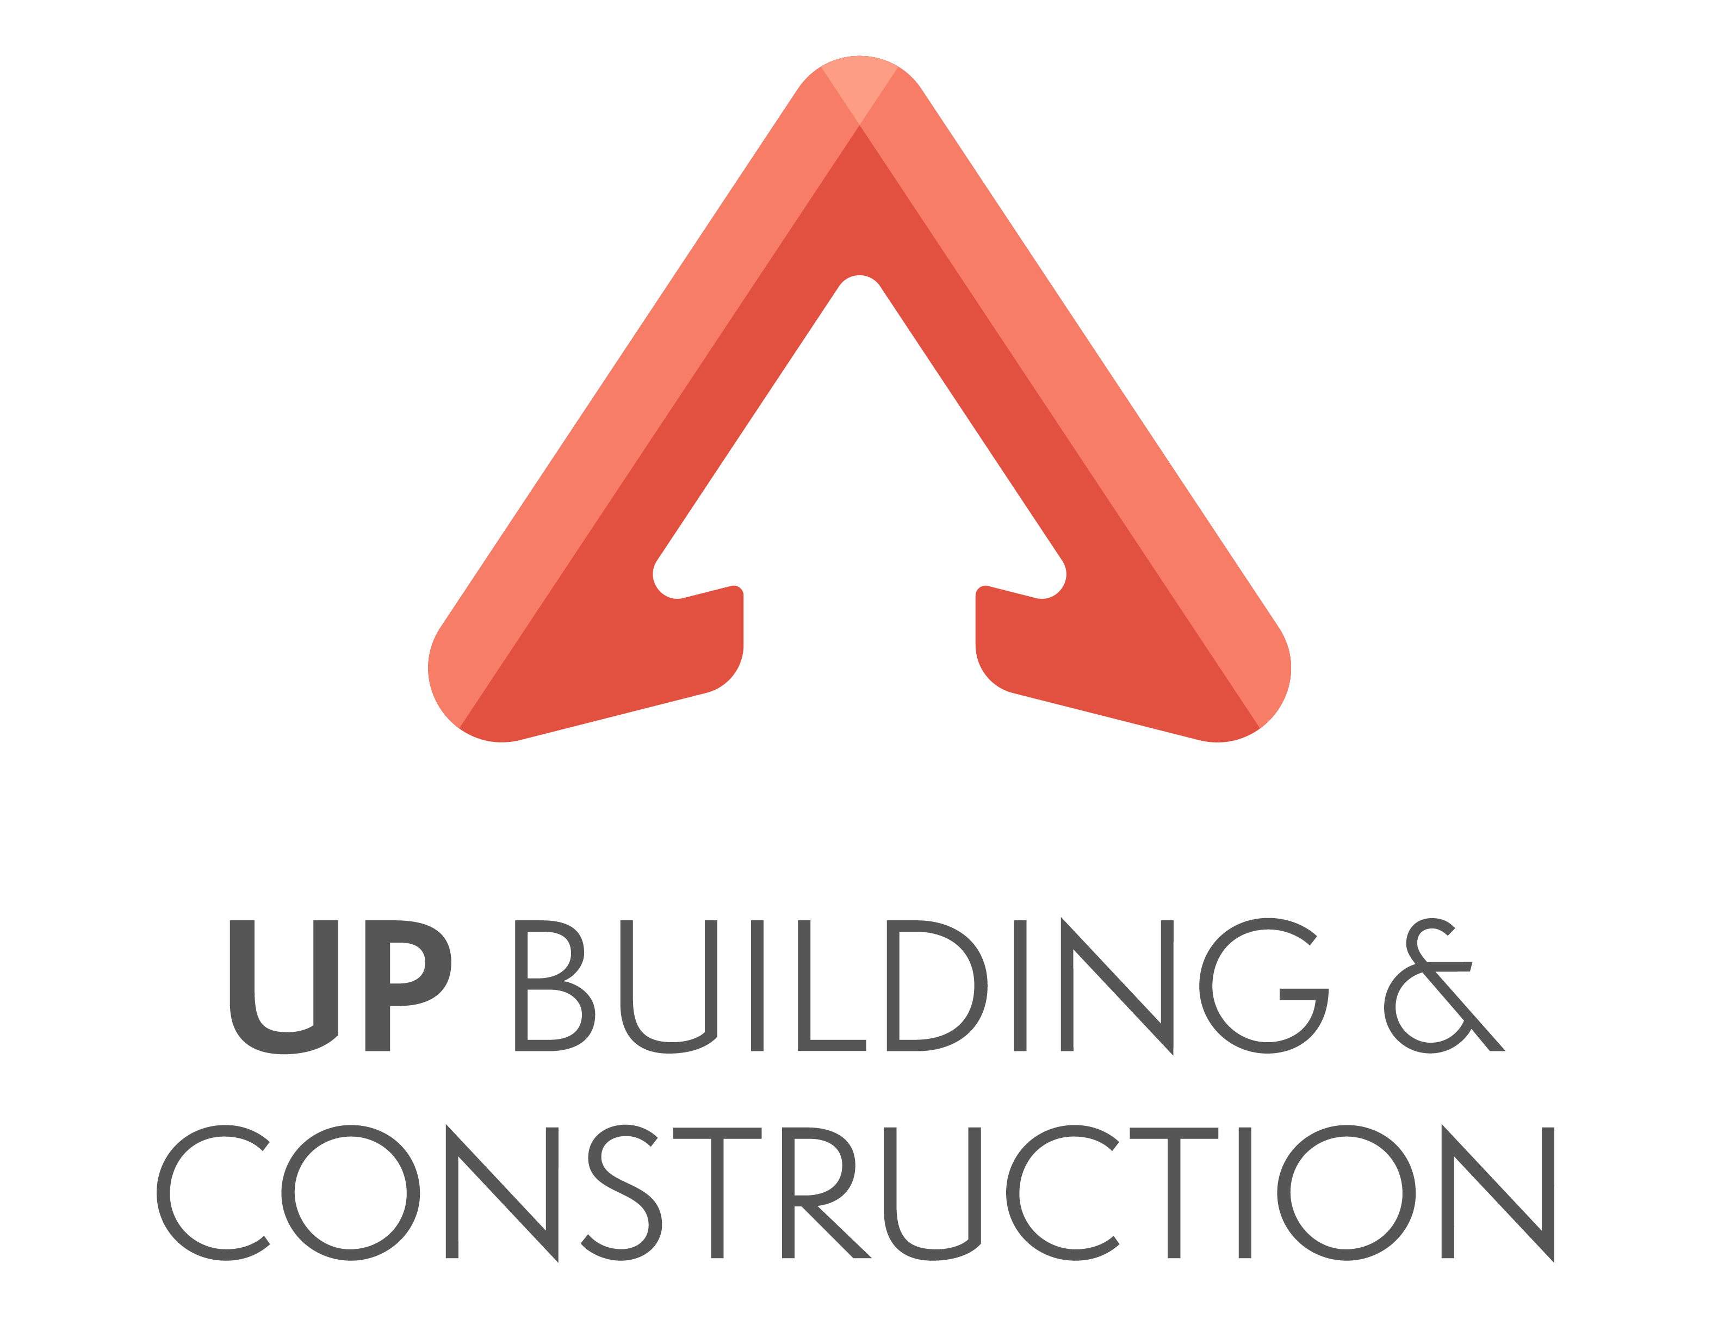 UP Building and Construction Pty Ltd

“Building dreams from the ground UP”

ABN 123 456 789

**Customer Engagement Policy and Procedures**

Contents

**Customer Engagement Policy and Procedures** 1

1. Policy and Procedure Statement 2

2. Scope 2

3. Policy Compliance 2

4. Context 2

5. Policy 3

6. Procedures 3

7. Dispute Resolution 4

8. Monitoring 5

9. Contact 5

1. Policy and Procedure Statement

**Policy Statement**

UP Building and Construction Pty Ltd is very much committed to provide their customers the very best building experience possible. This policy outlines how to achieve quality customer relationships and outcomes.

**Procedure Statement**

To deliver ultimate customer satisfaction, we must regularly and openly communicate with customers. The procedures below identify how this is to be achieved.

2. Scope

This document sets out the customer engagement procedures to be followed in all client interactions.

3. Policy Compliance

|  |  |  |  |
| --- | --- | --- | --- |
| **POLICY DETAILS** | | | |
| **Policy Name** | Customer Engagement Policy and Procedure | | |
| **Effective Date** | 1 March 2015 | **Policy #** | 00110 |
| **Date of last revision** | 1 March 2021 | **Version #** | 3 |

|  |  |  |  |  |
| --- | --- | --- | --- | --- |
| **VERSION HISTORY** | | | | |
| **Version** | **Author**  **and position title** | **Revision Date** | **Description of change** | **Approved by name**  **and position title** |
| 1 | Orshy Fredricksen  Legal Consultant | 1 March 2015 | New policy and procedure | Charlie Fredricksen  CEO |
| 2 | Orshy Fredricksen  Head of Legal | 1 March 2018 | Review and expand to clarify scope (articulate worker types) | Charlie Fredricksen  CEO |
| 3 | Adam Webb  Head of Operations | 1 March 2021 | Review, update procedure component in line with site expansion | Orshy Fredricksen  Head of Legal |

4. Context

Our vision is to be the most respected builder in Australia in the eyes of our customers, investors, workers and communities. In achieving this vision, we aim to make a net positive contribution to our communities, people and environment.

We know that the most sustainable places are founded through engaging with and responding to the needs of those who use them – our customers. Our customers are those with whom we have direct relationships – general public as well as investors. We choose to work actively with our customers, fostering productive, harmonious long-term relationships. We aim to understand, anticipate and respond to their needs and concerns as we know this is essential to delivering enriching customer experiences.

5. Policy

UP Building and Construction Pty Ltd is committed to delivering a consistent standard of service and amenity as well as a high level of customer engagement that enables us to best serve our customers’ needs and concerns.

We strive to:

* Be attentive to our individual customers and responsive to their needs and concerns
* Measure levels of engagement and satisfaction to ensure that we are meeting our customers’ needs and responding to their concerns

UP Building and Construction is committed to offering a distinctive customer experience designed to reflect and respond to local customers’ needs and concerns.

We strive to:

* Proactively develop and implement strategic responses to customer needs and concerns
* Develop and maintain active customer engagement programs that encourage listening to our customers as well as sharing knowledge and insights

UP Building and Construction is committed to developing meaningful partnerships with our customers by collaborating with them in ways that create opportunities and inspire innovation to meet our shared aspirations.

We strive to:

* Maintain a collaborative partnership approach that promotes mutually beneficial strategic opportunities within existing business arrangements and the whole of the business
* Encourage and support customers to embrace UP Building and Construction’s sustainability commitments and aspirations to be an overall positive contributor to our communities, people and the environment.

6. Procedures

All UP Building and Construction’s workers are responsible for customer engagement, whether we deal directly with our customers or whether we place the customer at the centre of the decisions we make.

It’s through the **little things done well** – from providing a consistent level of service and amenity to a decision that responds to a customer’s need or concern – that we show our commitment to our customers.

It’s also through the distinctive, **memorable experiences** we offer.

And it’s through **listening to our customers** and delivering on our promises to them. The passionate people who represent our brand all have a role to play in enriching the customer experience.

UP Building and Construction will enact this policy through implementing a Customer Engagement Framework. Ultimate responsibility for implementation and review sits with the UP Building and Construction’s Leadership Team.

**Briefing internal personnel and working with external agencies and clients**

All internal personnel must undertake thorough induction process to ensure all staff is familiar with workplace policies and procedures, reporting lines responsibilities, with emphasis on WHS requirements, to ensure safety at the workplace at all times.

When engaging with external agencies and clients, it is important that only staff with managerial responsibilities engage in discussion with external agencies and clients. Workers with no management duties **do not** provide professional guidance and/or advice. UP Building and Construction believes in transparent communication. Therefore, it is very important to inform external agencies and clients of all relevant information and to provide clear documentation as required by the legislation. It is compulsory for all employees to abide by the terms and conditions of a signed agreement/contract with a client/external agency. It is also required to follow relevant WHS procedures during site visits.

**Contracting with Clients**

Before contract finalisation UP Building and Construction must ensure the client understands, has access to and can comply with the following:

* Is over the age of 18
* Has approved finance for the contracted / estimated amount
* Understands the contract terms and conditions. An interpreter is available if required.
* Has capacity to fulfill the obligations in full
* Is not under the influence of drugs and alcohol
* Has access to the appropriate plans, specifications, addenda, and documentation pertaining to the building

7. Dispute Resolution

Common types of claims arising in construction projects include:

* the client claiming against the contractor for delay or defective works (i.e. poor workmanship);
* the employer claiming against a professional consultant for shortcomings in the design or a failure to properly supervise the works;
* a contractor claiming against the employer for delay or a change to the scope of works;
* a professional consultant claiming against the employer for non-payment of fees.

UP Building and Construction’s dispute resolution principles are as follows:

1. The parties need to communicate, preferably in writing or additionally, verbally – before the parties can activate any formal dispute resolution mechanism, whether under the contract, under statutory provisions or via a consumer protection agency they should attempt to resolve it themselves. **UP Building and Construction is committed to responding to all complaints within 48 hours, in writing.**
2. UP Building and Construction believes in open and transparent communication, both verbally and in writing. If for any reason parties are not reaching the desired outcome, they are encouraged to involve an independent third- party professional as a mediator. Either party shall give to the other notice of a dispute, disagreement or difference and at the expiration of **five (5)** working days.
3. UP Building and Construction is determined to find solutions for disputes that satisfies all parties’ needs. All construction work is covered by a 6-year warranty. Upon mutual agreement, any work under the warranty period must be completed by UP Building and Construction or, if the client prefers another company for rectification work, all costs must be covered by UP Building and Construction.
4. Parties should have the right to have their domestic building dispute heard by a court, rather than a tribunal, for equitable claims or when the amount in dispute would fall within the monetary jurisdiction of the county or district court (or equivalent intermediate jurisdiction in that state or territory’s judicial hierarchy).
5. Complaints must be handled with respect and professionalism as follows:

* Once client expresses disaffection regarding any aspect of the work, the project manager must validate the complaint and inconvenience in writing and initiate a conversation to investigate client’s intentions. Reassure the client that the company is determined to find mutually acceptable solutions.
* Offer to re-visit the issues and get it fixed with reliable contractors on the company’s expense as this is all covered by builder’s warranty.
* If a mutually convenient timeframe or actions cannot be negotiated, offer the client to organise the repair with other contractors and UP Building and Construction will cover the expenses.
* If no quick solution can be found for the issue, the complaint can be escalated to the HR manager to proceed with the formal dispute resolution process presented above.

1. UP Building and Construction must retain a copy of the communication with client regarding the complaint, including all project-related documentation and dispute outcome, for a minimum of 10 years. Any correspondence regarding the dispute, including the outcome of the dispute, must be kept on file either electronically or in printed format. These documents must be stored in a secure way, maintaining privacy and confidentiality. Documents can be presented in case of legal proceedings.

8. Monitoring

The Head of Operations monitors implementation of this policy and reviews its contents for relevance and accuracy every three years or as needed.

9. Contact

Adam Webb – Head of Operations

Ph: (02) 9244 4410

<<END OF POLICY DOCUMENT>>